**MIE1622 Assignment 4 Report**

**Yizhou Liu 1001139822**

* The result for part 2

Black-Scholes price of an European call option is 8.0214

Black-Scholes price of an European put option is 7.9004

One-step MC price of an European call option is 8.3461

One-step MC price of an European put option is 7.8329

Multi-step MC price of an European call option is 8.1579

Multi-step MC price of an European put option is 7.8317

One-step MC price of an Barrier call option is 7.6331

One-step MC price of an Barrier put option is 0

Multi-step MC price of an Barrier call option is 8.0618

Multi-step MC price of an Barrier put option is 1.8491

* Justify the number of steps and paths used for computations.

In our Black-Scholes pricing process and Monte Carlo pricing process, we used *252* steps and 5000 paths. The reason why we need a larger number of paths is that the standard deviation, or error, in Monte Carlo simulation would be smaller and the result tend to converge to a closed form. The more paths that one uses the better the approximation will be. However, for the computation efficiency purpose, we should not use too many steps, and 5000-path is large enough to show the trend and not takes too long time to reach the result. The reason why we use 252 as the number of step is that there are 252 business days in one year.

* Plot one chart in MATLAB that illustrates your Monte Carlo pricing procedure in the best way.

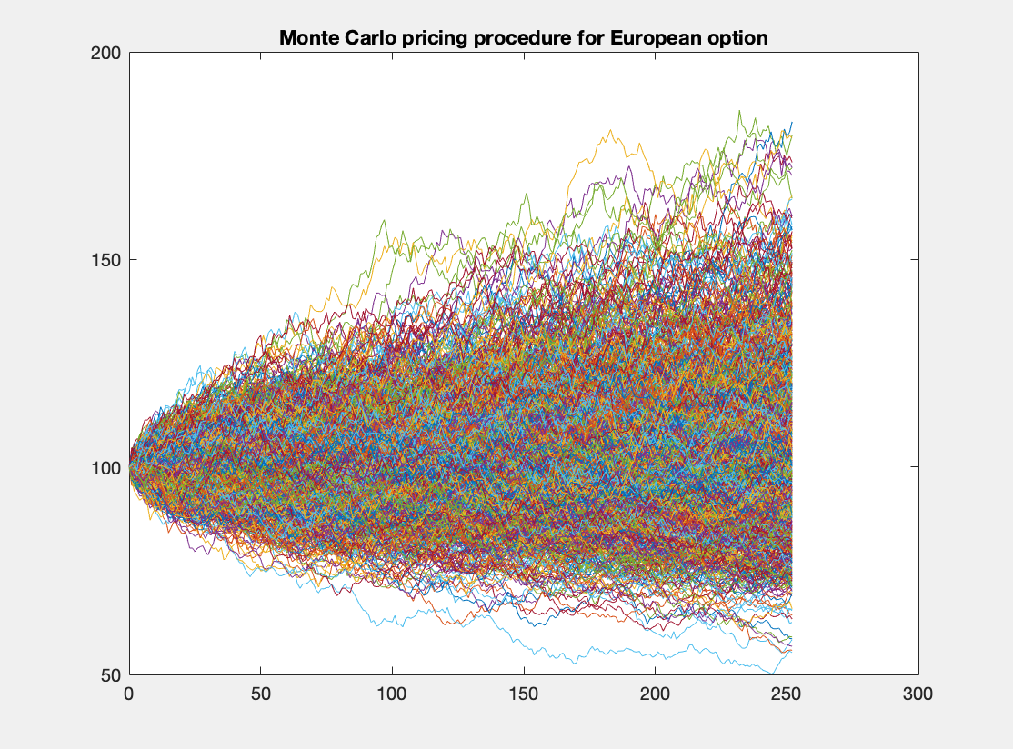

* Compare three pricing strategies for European option and discuss their performance relative to each other.

The results for Black-Scholes pricing strategy, one-step Monte Carlo strategy and multi-step Monte Carlo are very close to each other. The call and put option payoffs created by one-step MC simulation and multi-step MC simulation are very similar, so we can conclude that the number of steps does not have a significant effect on the accuracy of simulation. The number of paths may have an impact on the accuracy of simulation result.

* Explain the difference between call and put prices obtained for European and Barrier options.

From the results we can say that the prices of Barrier call options are similar to the European call options, while the prices of Barrier put options are significantly smaller than the European put options. In our case, the strike price is 105 and the barrier is 110. When the Barrier option hit the knock-in barrier during its life time, it becomes a European option. If it is a call option, it has more chance to reach the highest payoff. For the one-step Barrier option, when meet the knock-in barrier, it cannot be a put option, so the price would be 0. For the multi-step Barrier option, after meeting the knock-in barrier, it has more chance to be a call option and reach the highest payoff. However, it also exists small chance to become a put option. So the price for barrier put option is much lower than the European ones.

* Compute prices of Barrier options with volatility increased and decreased by 10% from the original inputs.

Volatility increased by 10%:

One-step MC price of an Barrier call option is 8.585

One-step MC price of an Barrier put option is 0

Multi-step MC price of an Barrier call option is 9.0063

Multi-step MC price of an Barrier put option is 2.5488

From the result we can say that the price of both Barrier call and put option increased when the volatility goes up. This may because the stock payoff would have more chance to hit the barrier and achieve a higher price when the volatility increased.

Volatility decreased by 10%:

One-step MC price of an Barrier call option is 6.9676

One-step MC price of an Barrier put option is 0

Multi-step MC price of an Barrier call option is 7.2777

Multi-step MC price of an Barrier put option is 1.5665

From the result we can say that the price of both Barrier call and put option decreased when the volatility goes down. This may because the stock payoff would have less chance to hit the barrier and achieve a higher price when the volatility decreased.

* Design your own procedure for choosing an number of time steps and an number of scenarios in MC pricing for European option to get the same price as given by the Black-Scholes formula.

Set a list of numbers of path to be [100, 500, 1000, 5000, 10000, 20000, 30000, 40000, 50000] and a list of number of steps to be [2, 12, 24, 252], use the grid search to find the step number and path number that corresponding to the minimum absolute value of the difference between MC pricing and BS pricing. So the optimal number of steps would be 2 and the optimal number of paths is 40000.